Making Google Docs, Slides, and Sheets Available Offline:
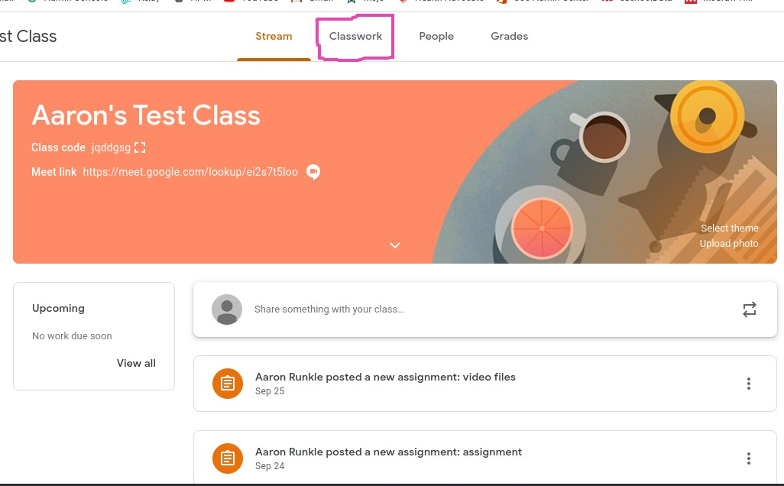
- Travel to your classroom drive folder either via google classroom or from finding it within your google drive. Below I will show you how to access this folder from Google Classroom.
3.
2.

4.

- Hold Down CTRL and select the google docs, slides, and sheets files you want to make available offline.
- Once selected use two fingers and click on your trackpad this will pull up the menu bar where you can move the slider that says “Available Offline”
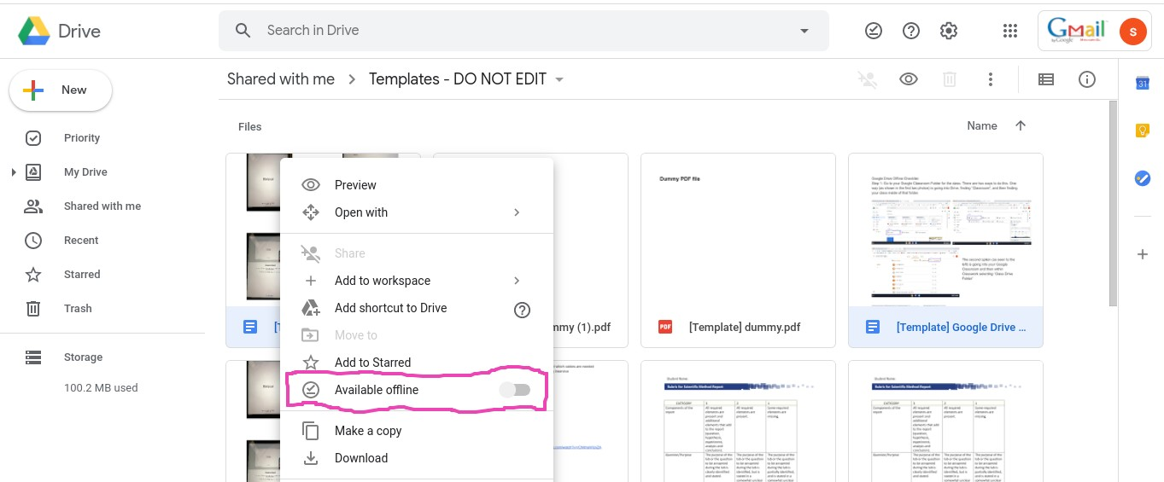

- Once this is completed these files can be accessed through your files app. To navigate here you will click on the bottom left hand launcher circle on the Chromebook screen. Then the arrow shown in the second photo, and then find the Files application.
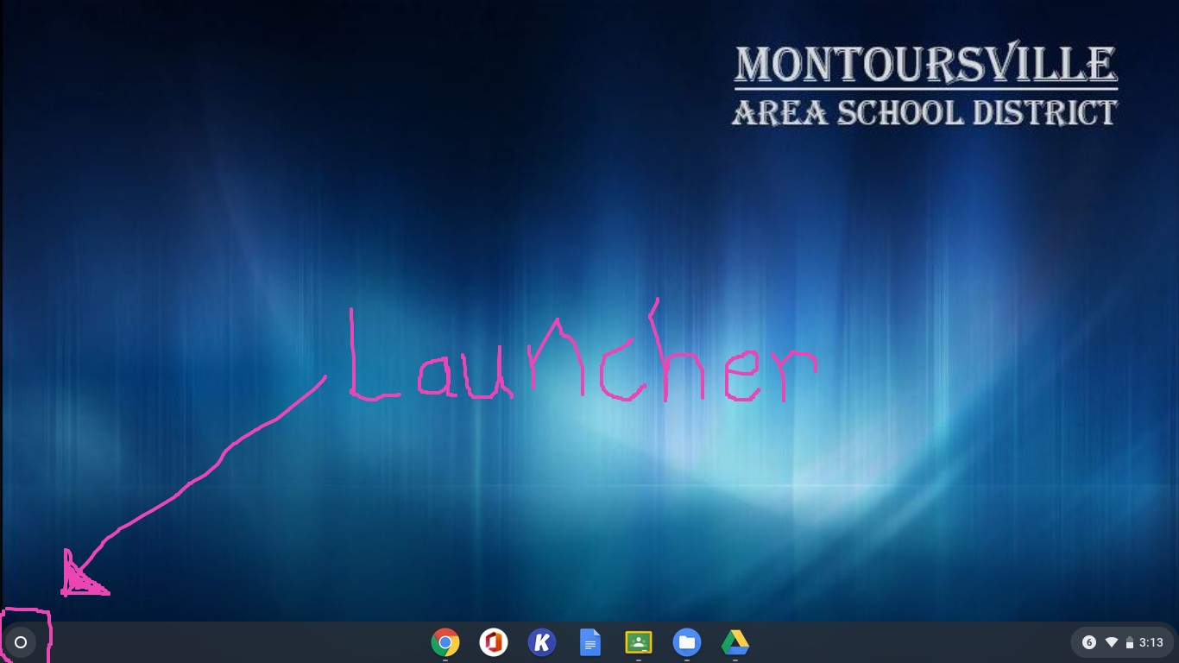

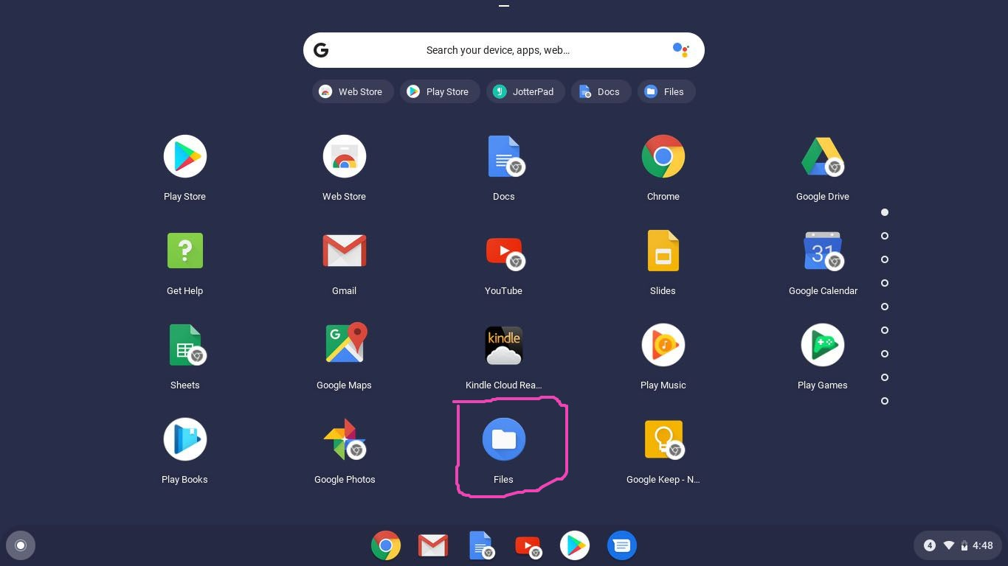

- Once inside of the files app you will see what is seen below. First you will select the drop-down arrow next to “Google Drive”, then “My Drive”, and then “Classroom”, from there find the class that you are looking for. Within there the files you made available offline from your google drive appear as offline!
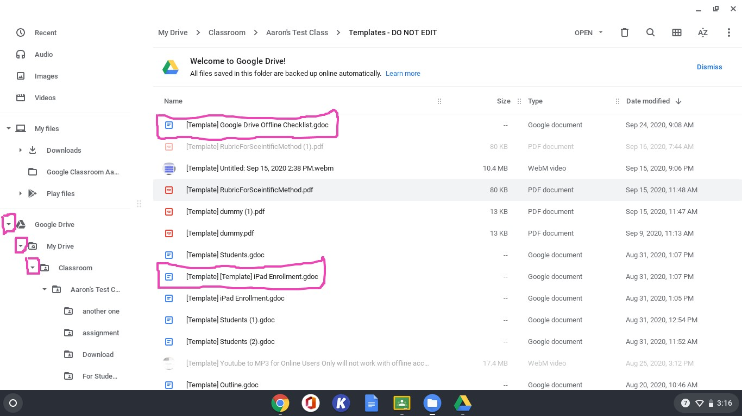

Making PDFs and Microsoft Office Documents Available Offline

Read that again, MICROSOFT DOCUMENTS therefore being Word, Powerpoints, or Excel, NOT GOOGLE DOCS, SHEETS, or SLIDES:

- Preface: You need to be assigning each of your PDFs or Microsoft Documents to your students as “A copy for each student” in your google classroom assignment. Then this strategy will work for the students!
- To start after the teacher has assigned PDFs click on the bottom right circle launcher, once this appears you can type in Files and select the blue app named files.
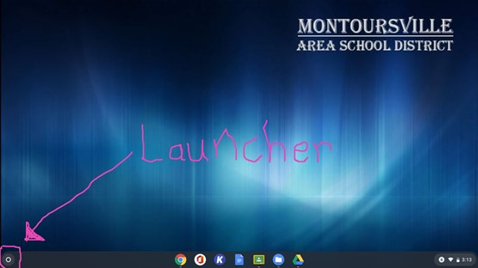

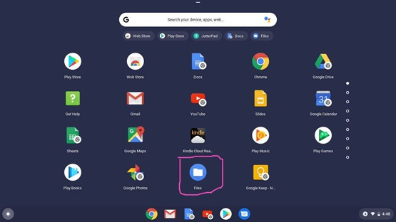

- Once this is launched you will travel to “Google Drive”, then “My Drive”, within there you will click on the ”Classroom” folder, and then find the class that your PDFs are in and you need to make it available offline.
- Once there hold down CTRL and select the PDF’s you would like to make available offline two finger click on those selected and click “Available Offline” once it is done syncing you're good to go!!!
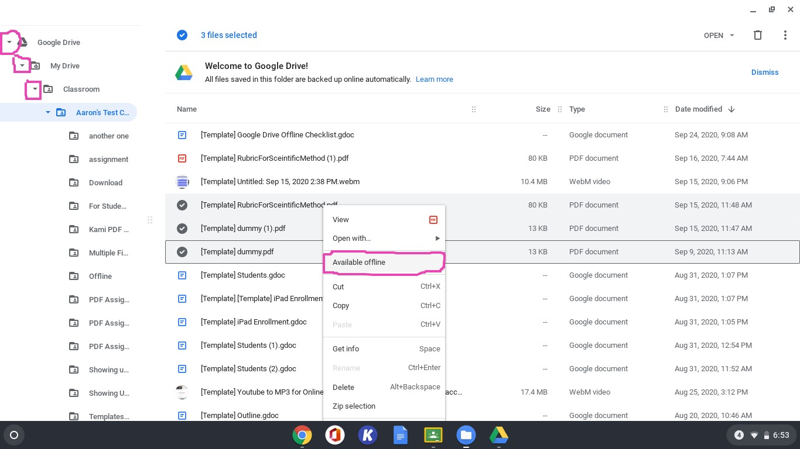

Making Videos Available Offline:
- Preface: If you wish to use this strategy for videos then your process for distribution of these videos will be changed, if you wish to still have your kids download them from google classroom then you may that is fine!
- If you are joining the dark side, then you will want to travel to your google drive and create a folder named after the lesson, week, or whatever works best for your videos. Add the videos you have made for your students that they will need for that week they are not here. From there you will right click on the folder you made and share this with your students in your class, and make sure they are only viewers of the folder. This will give your students access to this folder so when you add videos, they can two fingers click on the folder on their Chromebook and make all the videos inside available offline.
- So, for the students' side they will travel to their launcher at the bottom left side of the Chromebook and complete the same steps they did to find their Files app.
- Then they will click on “Google Drive”, then “Shared with me”, within here they will see the folder that you shared with them and if they two finger click on this folder they can make the whole folder “Available Offline” and all of the videos inside.
- This will then say at the bottom right “Syncing # Items” once this is finished all the videos inside will be available offline!!!!!

