Accessing Network Drives:
If you are not on the school Wi-Fi, you will need to be connected through the VPN.
Click on File Explorer
Click on “This PC”
Network Drives will be below.
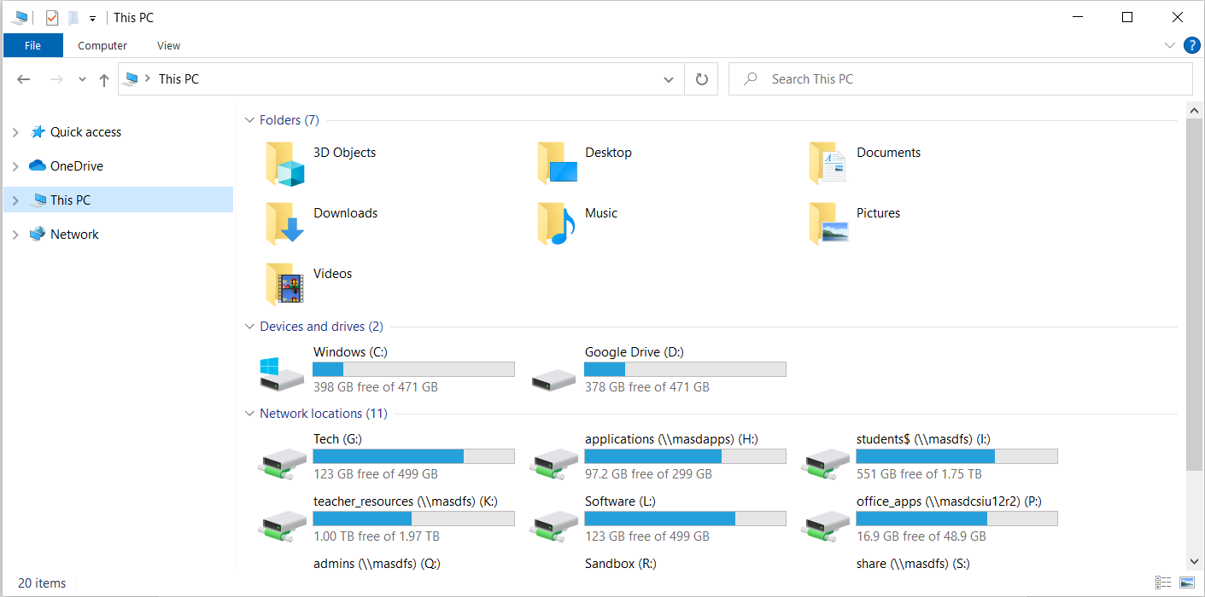

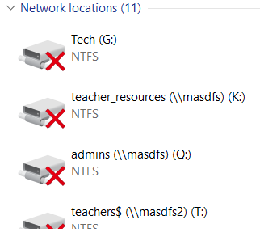
If the network drives appear with X’s:
Make sure you are connected to Wi-Fi or the VPN
Restart your machine

