Getting Started with OpenVPN

OpenVPN allows district staff to remotely access network resources (such as district servers and shared drives).
OpenVPN is already pre-Installed on most district computers, but if it is missing from your machine contact the Technology department for assistance.
- Double-click the OpenVPN Desktop Icon to get started. | OpenVpn  Connect
- If this is your first time opening the app, you can close the tutorial and enter the URL shown to the right. Click “NEXT” after typing the URL.
https://masdvpn.montoursville.k12.pa.us

2b. If a separate window pops up asking you to accept or reject, click “accept”.
- Enter your username and password into the respective fields. Leave both Check boxes unchecked, and click “IMPORT” to finish the setup process. | 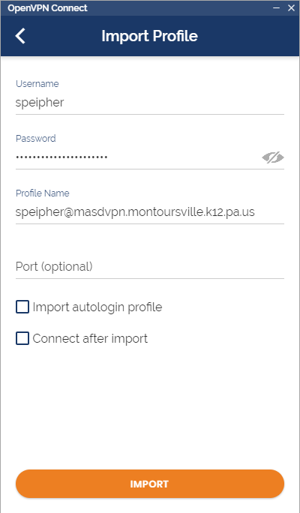
- Flip the “Switch” to turn on the VPN Connection. | 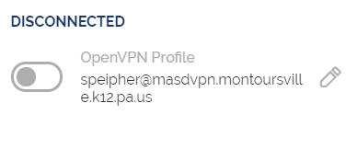
- You will be prompted to enter your password after the switch has been flipped.  - This step will also require an MFA response, so at this point you will receive an app notification or phone call to approve the connection. If you do not have the app or phone call set as your default MFA method, you can change that HERE. | 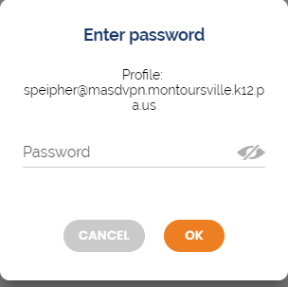
- Now that you are connected to the VPN, you have access to district resources such as shared drives, personal documents, CSIU apps, etc.  Please remember to connect and disconnect as needed to leave connections available for those who need them. | 